Arley Primary School |  | Topic: We Shall Never Surrender  Medium Term Plan 2021 | YEAR: 6 Term: Autumn 2
ESSENTIAL KNOWLEDGE:  This includes:  - Understanding when and why World War II took place.  - Understanding and exploring evacuation and rationing.  - Understanding key turning points during WWII  - Explore the sensitive issue of the Holocaust giving a deeper understanding and empathy.  - Explore the role of the woman during this period.  - Research Coventry and Arley during WWII |  | ENGLISH:  Texts:  The Boy in Striped Pyjamas, Goodnight Mr Tom extracts, Letters to relatives, The Piano animated clip, The Diary of Anne Frank  Word War 2; Armistice Day poetry | History Targets:  By the end of this unit children should be able to:  - Use chronology, secure knowledge and understanding British, local and world history, establishing clear narratives within and across the periods they have studied.  - Make connections, contrasts and trends over time and develop the appropriate use of historical terms.  - Address and sometimes devise historically valid questions about change, cause, similarity and difference, and significance.  - Construct informed responses that involve thoughtful selection and organisation of relevant historical information.  - Understand how our knowledge of the past is constructed from a range of sources.  - Know that people in the past represent events or ideas in a way that may be to persuade others.  - Understand and describe in some detail the main changes to an aspect in a period in history;  - Identify and note connections, contrasts and trends over time in the everyday lives of people;  - Examine causes and results of great events and the impact these had on people;  - Describe the key features of the past, including attitudes, beliefs and the everyday lives of men, women and children.
KEY QUESTIONS:  - Why did the war begin?  - Who was Adolf Hitler?  - When, where and why were children evacuated during World War II?  - What is rationing and how did the people adapt to deal with reduced product availability?  - What was the importance and significance of the role of women during the war?  - What was the Holocaust and what were some of the events that took place?  - What were the key events that took place during WWII?  - Can I order the key events of WWII on a timeline including the role of Sir Winston Churchill?  - What was the war like in our local area? (Blitz- Coventry cathedral- Arley- recounts/photos) |  | Science:  Electricity  • associate the brightness of a lamp or the volume of a buzzer with the number and voltage of cells used in the circuit  • compare and give reasons for variations in how components function, including the brightness of bulbs, the loudness of buzzers and the on/off position of switches.  • Use recognised symbols when representing a simple circuit in a diagram
ICT/Computing:  Privacy and security. (see scheme)  Bletchley Coding. (Code Workers) |  | Homework/Independent Learning:  Timetables Rock Stars  Spellings  Reading
ART / D & T  Art: Sculptures inspired by the Holocaust, sketches exploring holocaust drawings and art.  D and T: Cooking rationed food/stew. | MATHS:  White Rose Y6 |  | Music:  Kapow: Songs of World War 2  Glenn Miller WW2 music; Schindler’s List music. | VISITS & ENRICHMENT  The Holocaust Museum (Nottingham – Leo’s Journey for KS2)/ Meeting a Holocaust Survivor  War Museum.

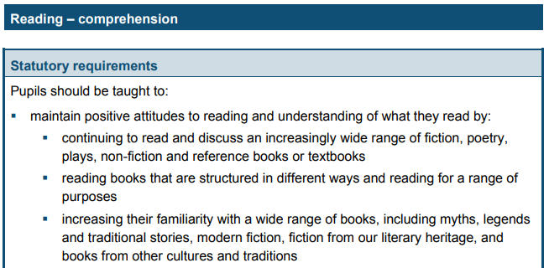
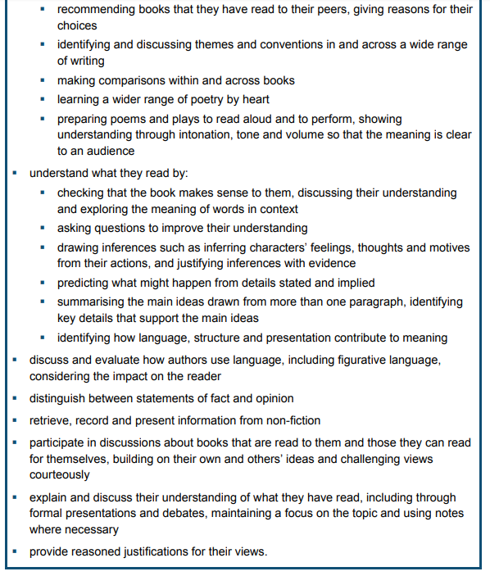
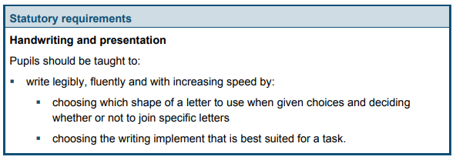
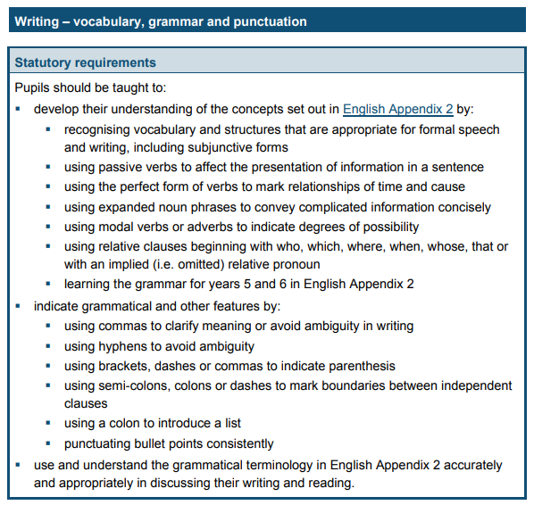
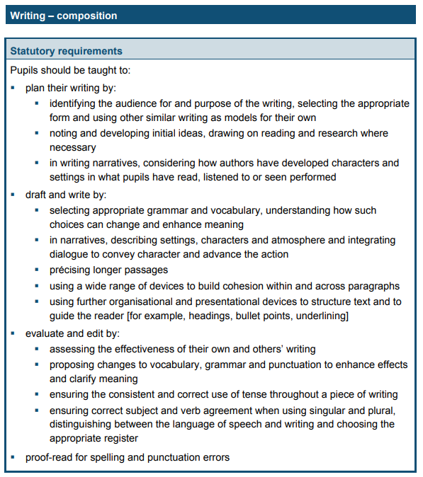
Year 5 and 6

