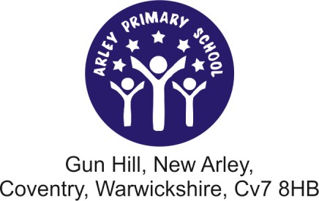

Thursday 8th February

Governor feedback - School Trip to Bosworth Battleﬁeld

Dear Parents and Guardians,
As part of our ongoing role, the School Governing Body are required and have the special privilege to attend and visit the school regularly, monitoring and assessing progress of the children and teaching staff.
These reports are available to read on the School website and a hard copy can be requested in school if you do not have internet access.
As we hope you will agree, school trips are an important and beneﬁcial way to reinforce the curriculum outside of the class room and play a key part in engaging our children’s interest.
I was able to join the school visit to Bosworth Battle ﬁeld on Tuesday and have asked the school to send this letter home to let you know how impressed I was.
Firstly, thank you parents and children for taking Mrs Riley’s sound advice on layering up. All of the children were suitably clothed, and after a very long walk through the muddy ﬁelds before lunch we were grateful for our snow boots wellies and extra layers.
From start to ﬁnish, your children were so well behaved. I think the coach driver and centre staff were quite impressed.
I’m sure by now you have been told all about their exciting day and seen the crest stamped paper book mark that they have brought home to remember their trip.
There were a few children selected to model battle wear and armour, but even the ones that didn’t physically join in, enjoyed asking questions and exploring the items on display.
There were several schools visiting whilst we were there. A member of the public that had paid to visit approached the tour guide and Mrs Riley at the end of our trip to say how impressed he was at the incredible behaviour of the children.
So thank you,
Teaching staff, parent helpers and children, for making a good impression, and Arley community proud. From
Emma Hunt
on behalf of the School Governing Body

