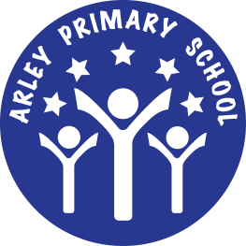 Impact Report on the use of the PE and
Sport Premium Funding 2014-2015

- Key Actions Taken:
  - Increase opportunity for both Key Stages to participate in clubs and sporting activities.
  - Continue to update and purchase new equipment for the new building.
  - Provide training opportunities for KS1 staff initially.
  - Look in to the prospect of an apprentice to support delivery of P.E
  - Provide staff with Arley PE kit.

- Impact of actions on learning:
  - More clubs have been offered to children during and after school increasing overall participation levels across the school therefore keeping more of the children active including Boxercise and Bowls.
  - Children continue to have access to better and a wider range equipment to increase their enjoyment of PE and involvement in sports they may not have had access to before. Large shed purchased to store games equipment outside encouraging staff to use a wider range of resources in lessons.
  - Teacher confidence in delivery of lessons increased as a result of teaching with and observing qualified coaches.
  - TA identified to complete NVQ L3 in supporting the delivery of P.E
  - More staff delivering PE in correct kit, setting the right example to children.

