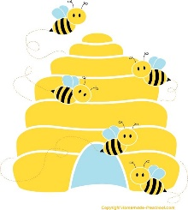
The Hive
Breakfast and After School Snack Menu
After school menu is a light snack and is not intended to be a substitute for an evening meal.
Breakfast Club menu
Selection of cereal or toast/bagel with butter and or jam.
Drink: Milk, water, or sugar free squash
After School Club menu.
 | Monday | Tuesday | Wednesday | Thursday | Friday
 | Toast with beans/spaghetti. | Scotch Pancakes with a choice of toppings | Ham or cheese Sandwich | Waffles with a choice of toppings. | Crumpets with spread or jam.

*Daily Desserts of Fresh Fruit, Yogurt or Jelly*
Drink choice: Milk, water and sugar free squash will accompany our snacks.

